**MERCIADO AMUSEMENT PARK**

**User Guide**

**Batch code: 2206F1**

**Documentation**

**GROUP MEMBER:**

|  |  |
| --- | --- |
| **ABDULLAH KAMAL** | **Student1345289** |
| **ARHAM RAO** | **Student1388281** |
| **MUHAMMAD AHSAN MAZHAR** | **Student1386879** |
| **MUHAMMAD DANIYAL** | **Student1386877** |

Acknowledgements:

We express our love and respect to our beloved project supervisor "**Miss Shumaila Naz**" for giving guidance throughout the work.

For appreciating us and making to present and work on this project. We are very thankful to her and her encouragements throughout the E-Project.

"With a great mentor like her, I am sure that life will be a successful journey, but

I never knew she would make a journey of this first e-project such an interesting, learning and polishing us for our future career and plans

I cannot express my gratitude towards her."

Secondly, We are very thankful to **"Aptech Institute Of Computer Education"** for providing us, and most importantly giving us the opportunity to learn more to prove ourselves, giving us a chance to implement what we all had learned, and to start thinking and being creative.

Last but not the least, we are thankfull to our colleagues for co-operation for helping and encouragements.

TABLE OF CONTENTS:

**HOME PAGE:** 5

**NAV BAR:** It consist of all the categories and their linking through a dropdown menu. It consist of the pages of contact us, order us and about us. It is fixed in the top. So, user doesn’t need to scroll again and again. 6

**MAIN BODY:** It is divided into three columns which includes our 5 categories with their proper linking and gifs in the left nav bar. 6

**FOOTER:**  it includes another nav bar which is consist of quick links i . e order us, about us and feedback form. Services i . e home, categories, contact us and a map. 7

**CATEGORIES:** 7

BRANDS**:** 8

**CONTACT US:** 13

**restaurants:** 14

**ABOUT US:** 15

**GALLERY:** 15

HOME PAGE:

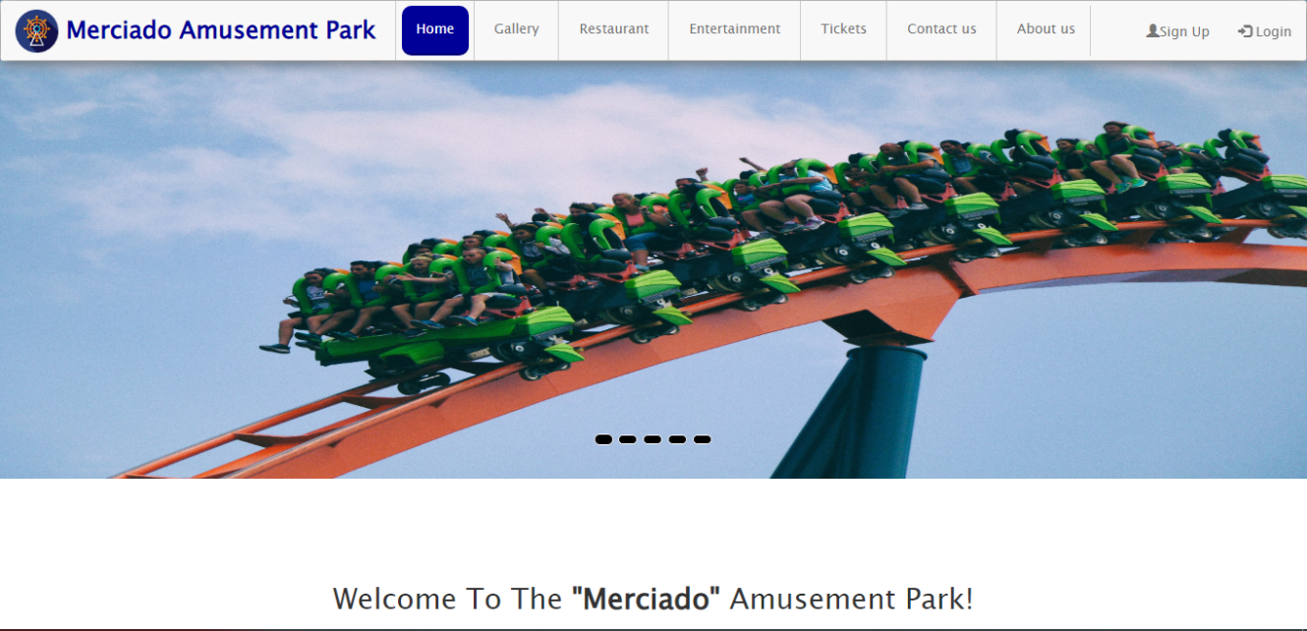

The homepage of **Merciado Amusement Park** gives you all the information about the

products through **NAV BAR** in the header. The main body includes an

Background image with images on which the I hover classes are applied

# **NAV BAR:**

It consist of all the categories and their linking through a dropdown menu. It consist of the pages of Home, about us, contact us and gallery. It is fixed in the top. So, user doesn’t need to scroll again and again.

Footer:

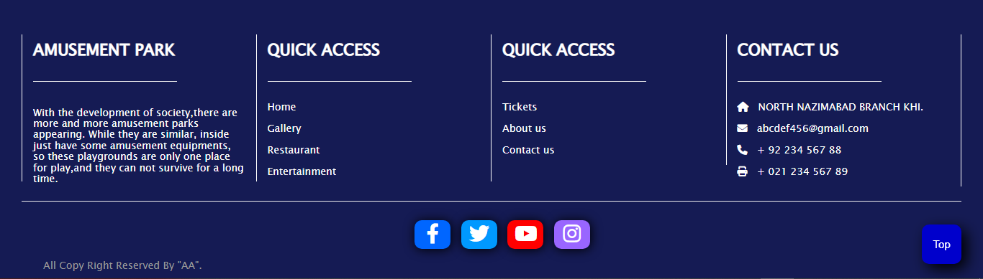

It includes another nav bar which is consist of quick links i.e. order us, about us and feedback form. Services i.e. home, categories, contact us .

# **Restaurant:**

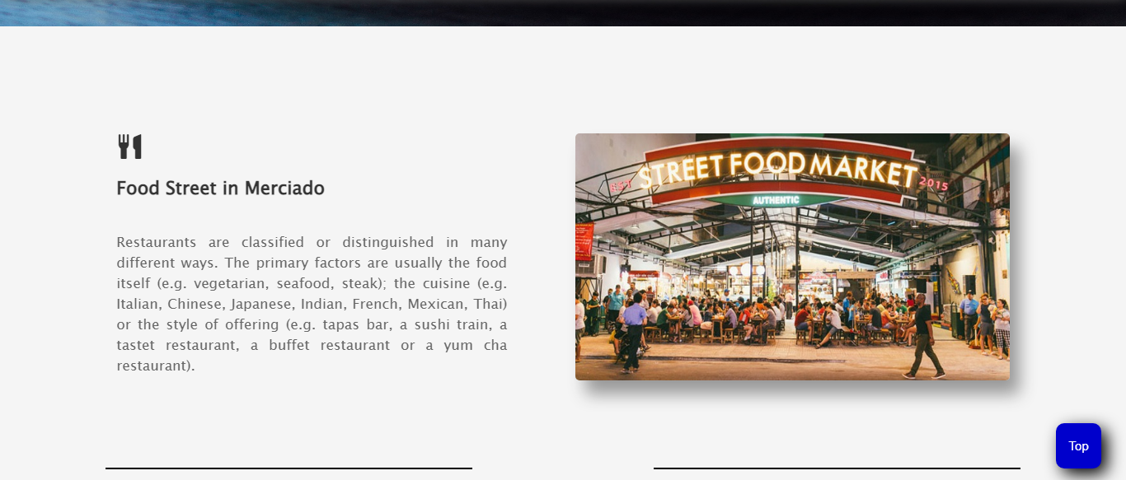

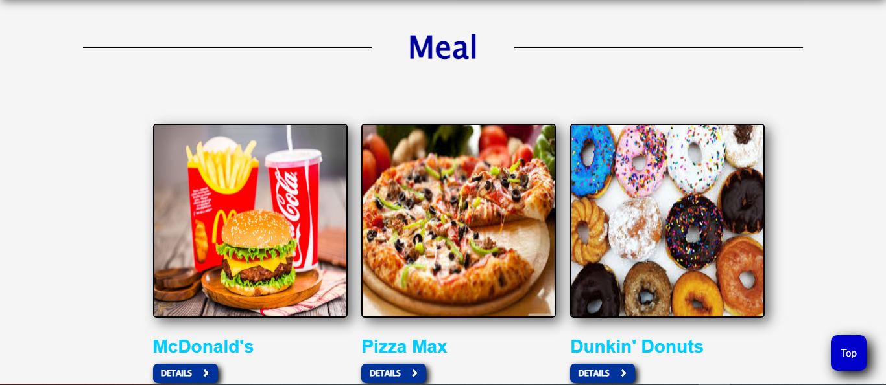

GALLERY:

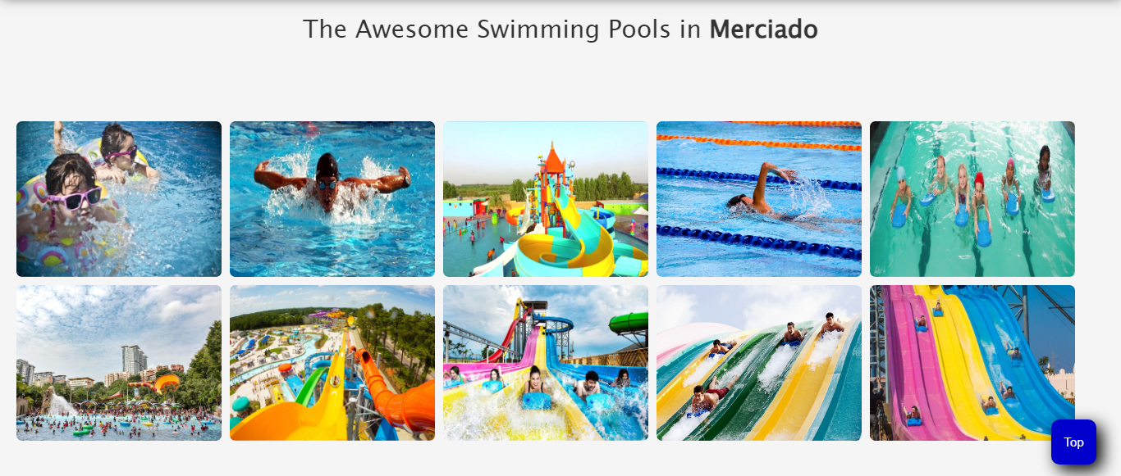

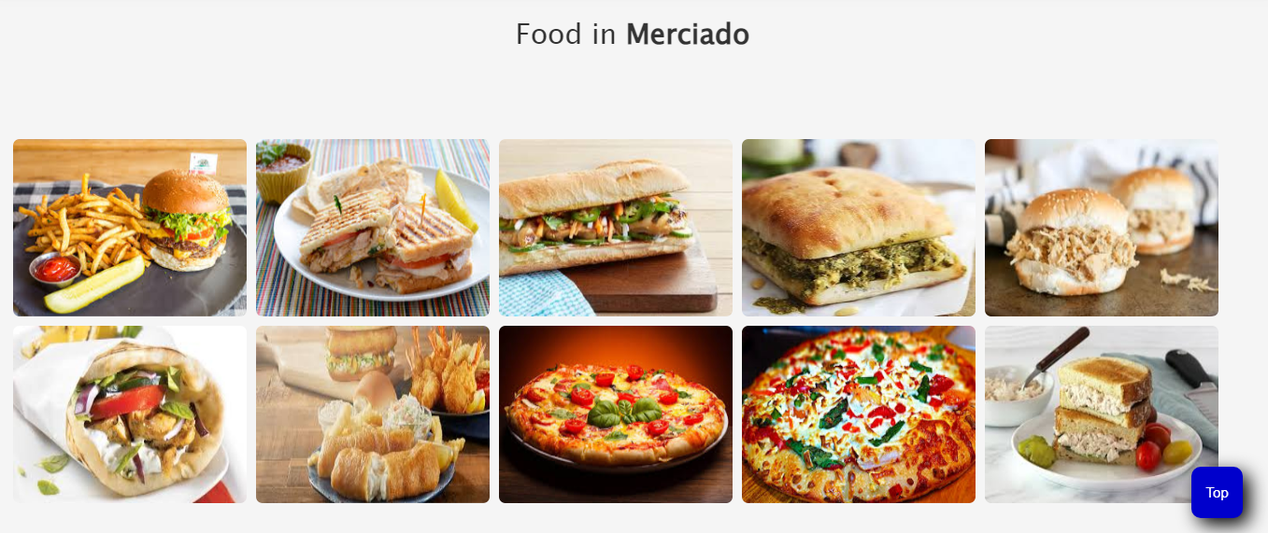

Contact us

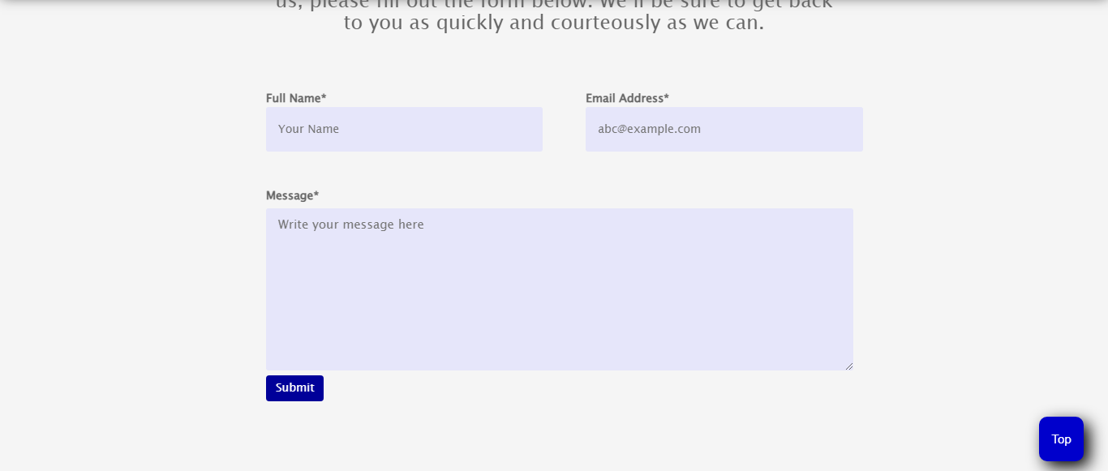

The contact us page is consist of a form. You can connect us or talk to us just by filling this small form and typing the message. The company will reply you hardly in two days max. This page is also consist of navs in both header and footer.

ABOUT US

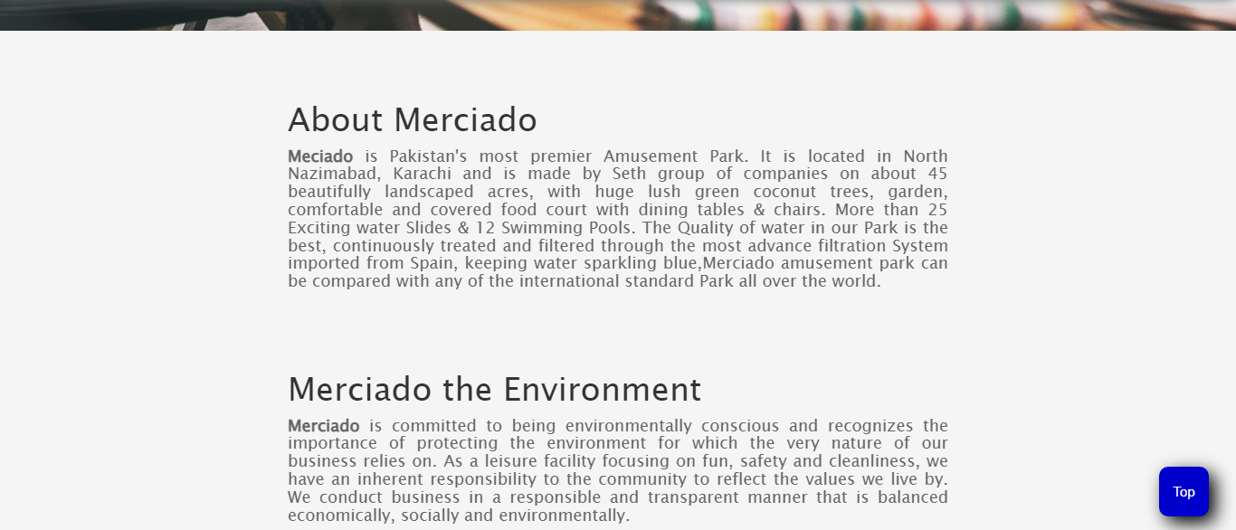

This page gives you the complete details about us. And our products